CASE STUDIES

Name: MUDDANAGIRI DURGA SAI MANASA

Roll.No: 2520030500

Section: 1[Practical]

Task 6: File Permissions
Objective: Practice viewing and changing file permissions using chmod.

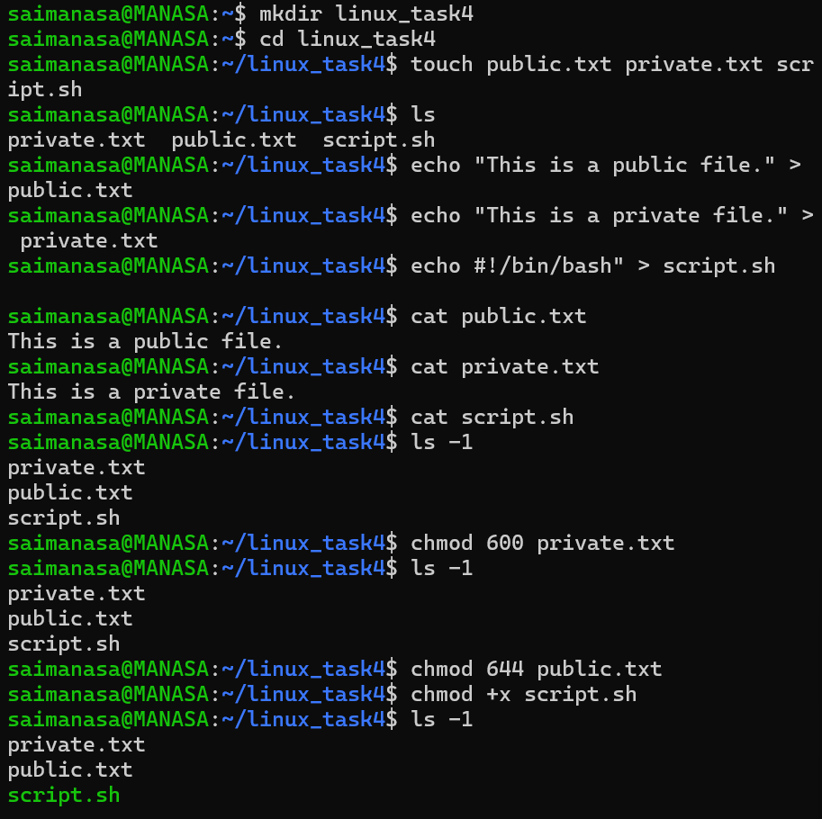

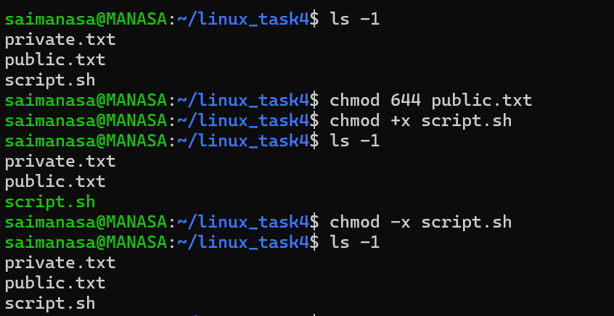

Task 7: Permission Lab
Objective: Explore the effects of read, write, and execute permissions.

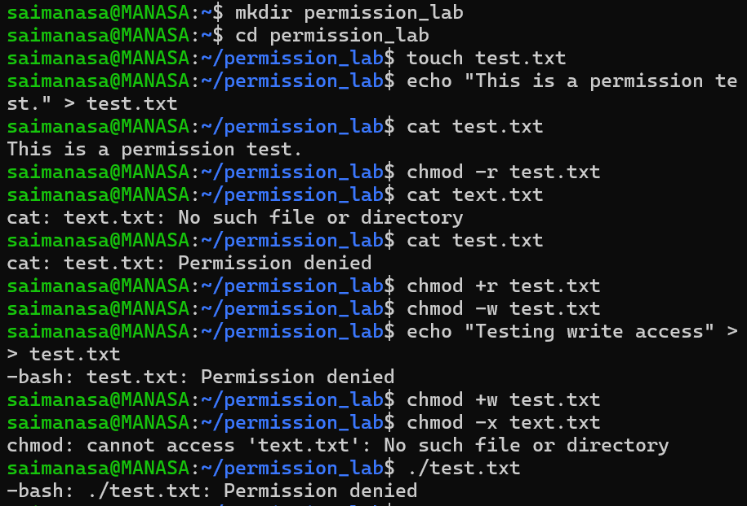

Task 8: Backup and Restore Files
Objective: Practice backing up, removing, and restoring files using cp, mv, and rm.

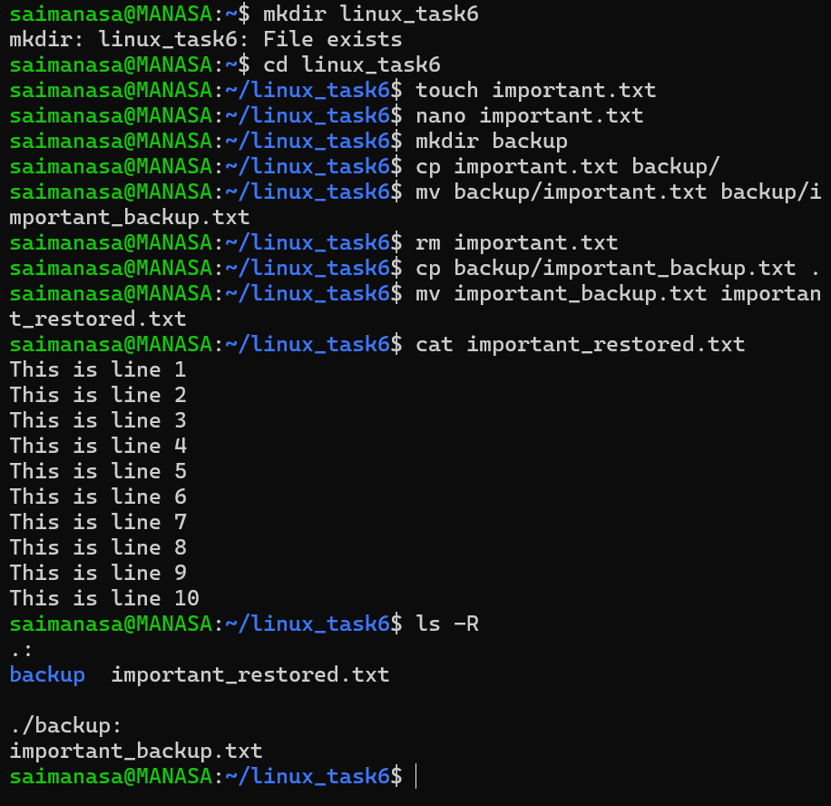

Task 9: Project Directory Management
Objective: Practice organizing a project with directories, viewing file contents, and managing files with cp, mv, chmod, and rm.

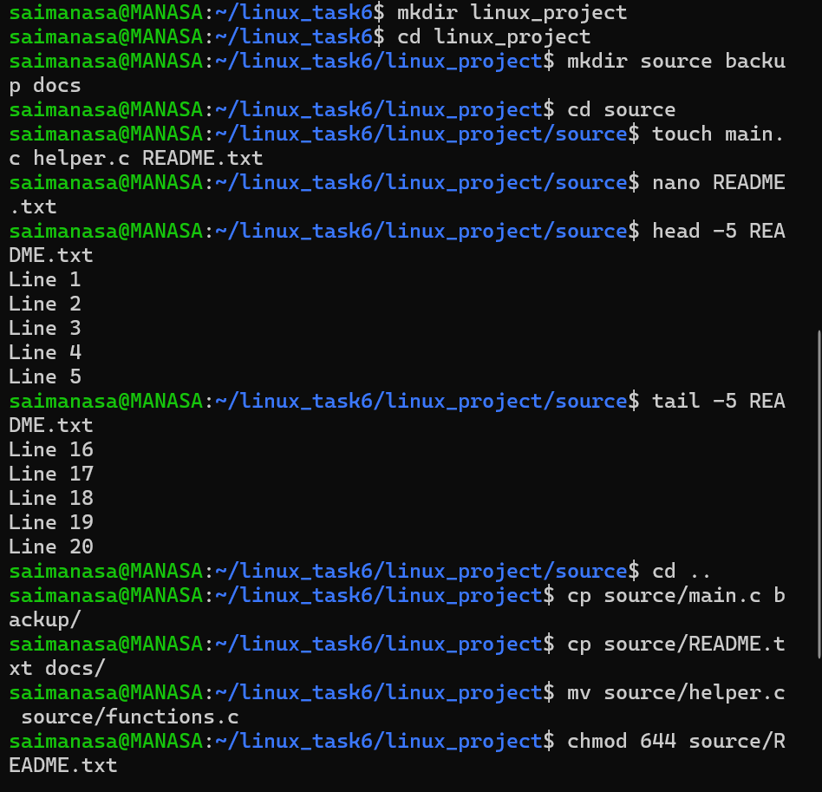

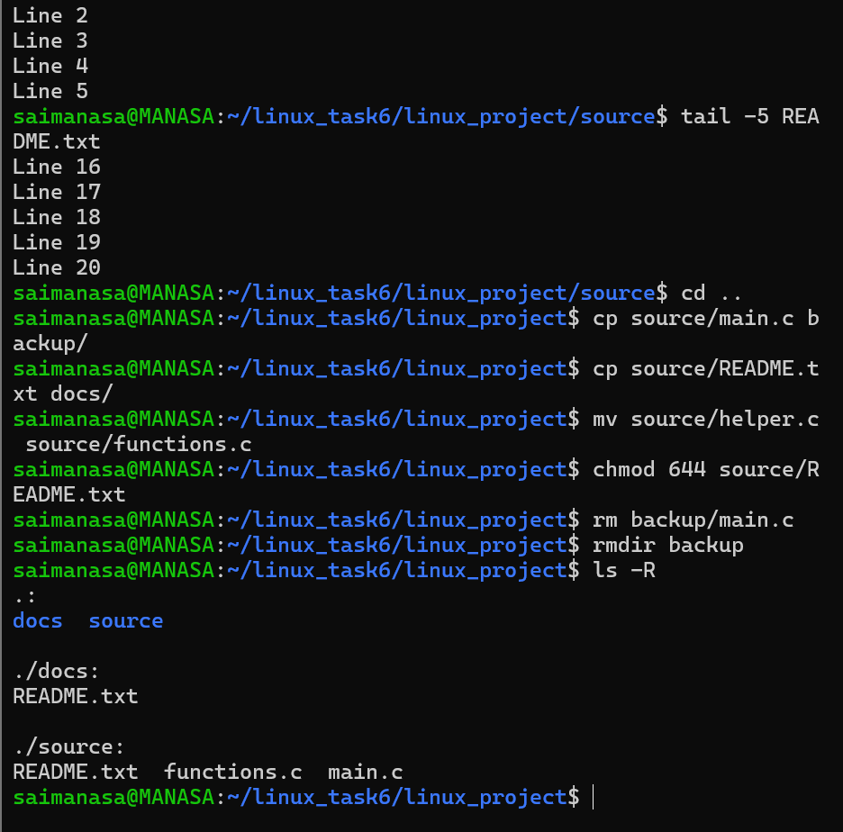

Task 10: Student Portal Project Setup
Objective: Practice building a multi-directory project structure and managing files with cp, mv, chmod, and rm.

